**Planning**

**1.Game introduction**

the World conquest is a strategy board game, players strive for global domination by capturing domain and establishing foreign policy.

**2.pert chart**

|  |  |  |
| --- | --- | --- |
| Stage | Mission Description (task) | Duration |
| Planning and design | A. Requirement design | 5 days  2/01/2024-2/05/2024 |
| B. Initial design (analysis the rules of the game, determine the features and requirements needed for the online version of the game) | 2 days  2/05/2024-2/06/2024 |
| C. Write high design documentation | 8 days  2/07/2024-2/16/2024 |
| D. Write low design document (formulate the core concept and mechanism, and design the game design document) | 5 days  2/19/2024-2/23/2024 |
| E. UI design (map, bottom, animation, interactive changes) | 5 days  2/26/2024-3/01/2024 |
| Development | F. Coding | 30 days  3/04/2024-4/12/2024 |
| Testing | G. Functional test: unit test and integration test | 3 days  3/15/2024-3/19/2024 |
| H. User test | 2 days  3/29/2024-4/01/2024 |
| Optimization and review | I. Fix and optimize, report | 10 days  4/15.2024-4/26/2024 |

|  |  |  |  |  |  |  |
| --- | --- | --- | --- | --- | --- | --- |
| Task | Days | | | | | Critical path |
| Duration | Earliest start | Earliest finish | Latest start | Latest finish |
| A | 5 | 0 | 5 | 0 | 5 | yes |
| B | 2 | 4 | 6 | 5 | 7 | 1 |
| C | 8 | 6 | 15 | 7 | 18 | 1 |
| D | 5 | 15 | 20 | 15 | 22 | yes |
| E | 5 | 20 | 25 | 20 | 25 | yes |
| F | 30 | 25 | 55 | 25 | 60 | yes |
| G | 3 | 35 | 38 | 40 | 43 | 5 |
| H | 2 | 45 | 47 | 45 | 50 | yes |
| I | 10 | 55 | 65 | 60 | 70 | 5 |

**2.1 Planning duration:**

70 days, 5 working days/week gives 12 weeks

**2.2 Non-critical tasks and slack time:**

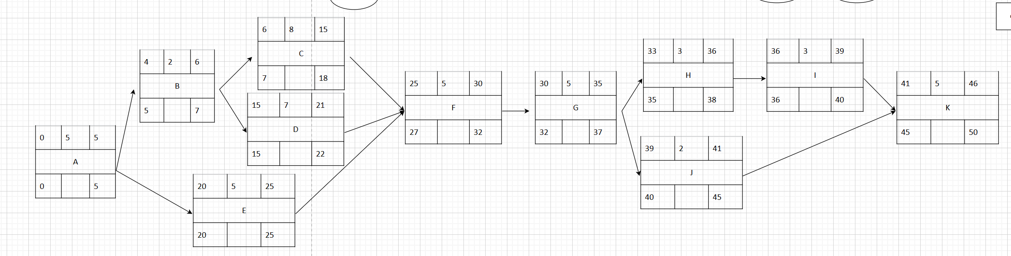

Task B: 1 day

Task C: 1 day

Task G: 5 days

Task I: 5 day

**3.Gantt chart**

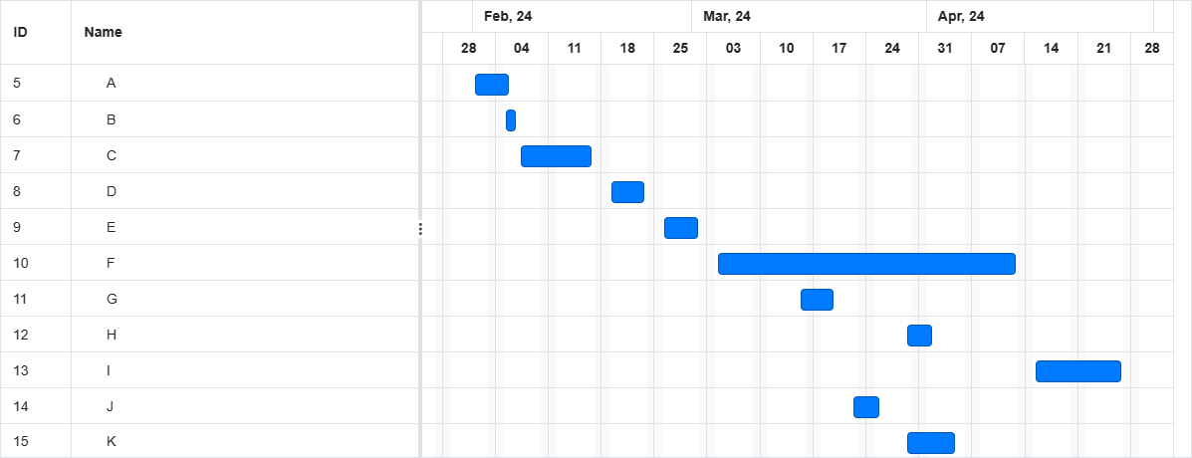

**4.Risk:**

There are a number of uncertainties that arise when executing the commands in this document. The following is an introduction of the risks when developing a software.

**4.1.1 technology risk:** the smoothness and fairness of the game is affected by network stability and latency. If the network connection is unstable or the latency is high, it can lead to synchronization issues between players, affecting the fairness and experience of the game. If If at any stage is not completed within the specified time which causes a delay, it is advisable to initiate plan B. If the project is still not completed, it may be necessary to sacrifice certain details or unimportant elements.

**4.1.2 people risk:** it is about the health problem of group members. To prevent delays in project caused by employee illness, each employee needs to understand the responsibilities of other team members.

**4.1.3 requirement risks:** changing requirements for game features and design can lead to duplication of development tasks, delayed progress, and other issues. In a certain sprint period, the analysis was left incomplete, and the conclusions were inaccurate. The group can adopt agile development method and divide the whole project into several small goals or tasks.

**4.1.4 organization risks:** lack of the abilities and qualities of management include leadership, strategic planning, and awareness and response to risk management. Prepare a briefing document for senior leadership, highlighting the substantial impact of the project on achieving the strategies goals of the business.

**4.1.5 estimation risks:** the first is about cooperation and communication between individuals. For example, some of people absent from a routine meeting or seminar or they quit, which lead to staff turnover. In this case, the group members need to organize meetings regularly and document sharing in order to communicate in a timely manner and examine the challenges that emerge. Inaccurate time estimates led to project delays, for example, the UI designer didn't finish the drawing or the design documentation lacks of clarity and logic. It should be regular meetings to share progress and adjust plans.

**5.Team task allocation**

* Sun Weiyi: high design document, planning document, sprint document
* Zhang Yaowen: low design document
* Tao Yiwen: UI design
* Max Wang: coding, process document, software document
* Wu Tong: coding, testing document
* Song Zhenmao: planning meeting notes, testing